Student’s Name: Kibet Brian
Admission Number: 190814
Lecturer’s Name: Mr. Talo Harrison
Course Unit: MST 8303 Penetration Testing, PT
Course Code: MST 8303
Lab - Scanning for Vulnerabilities Using OpenVAS
Date: August 15th, 2025
Lab - Scanning for Vulnerabilities Using OpenVAS
Pulling the OpenVAS Docker image.
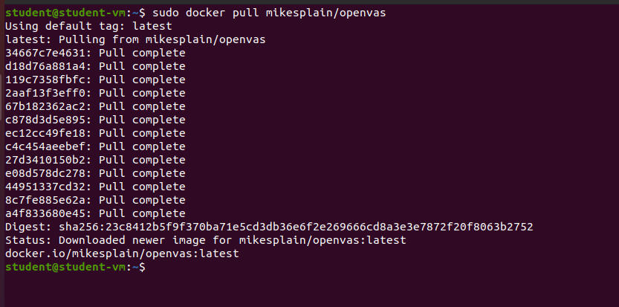

Running the container.

Openvas docker image Is available. 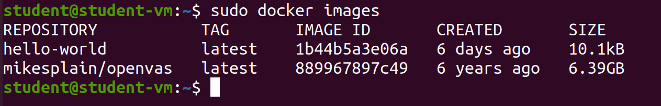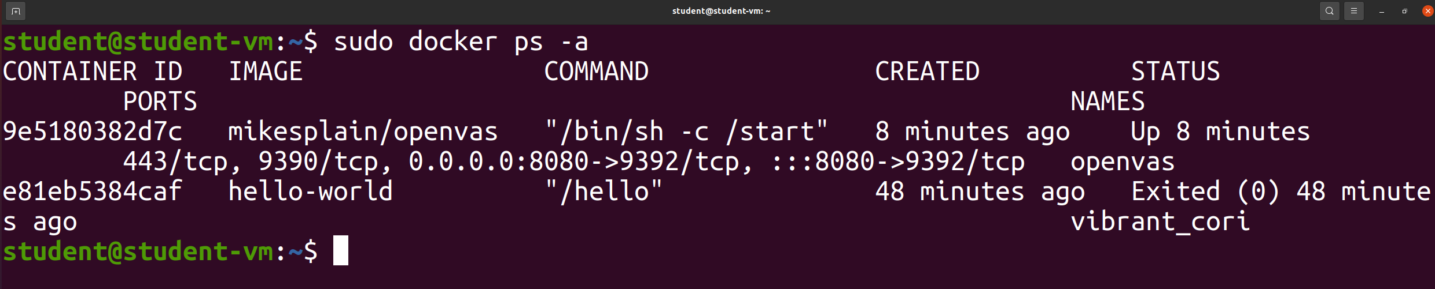

Attaching the docker container image. 